

Product Guide

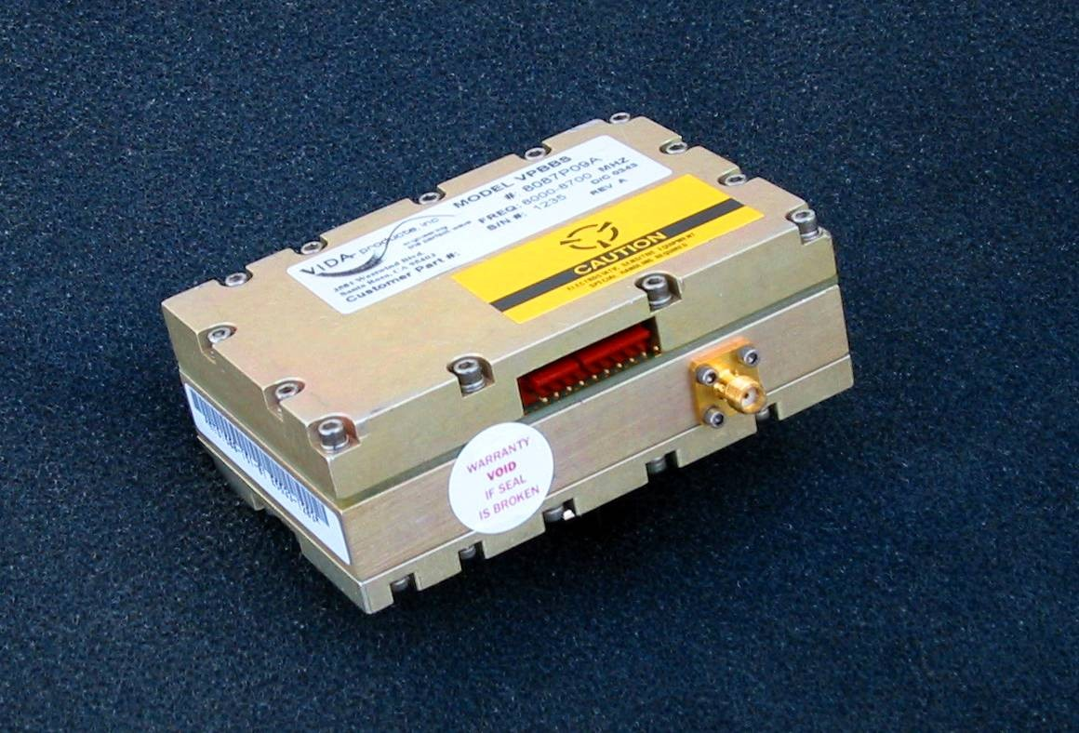
VPBBS Series

High Value

Frequency Synthesizer

3579 Westwind Blvd., Santa Rosa, CA 95403

Phone 707-541-7000, FAX 707-541-7030

Table of Contents

GENERAL DESCRIPTION …………….…………………………..……………….. 3
KEY FEATURES …………………………………….…………..…………………… 3

ypical Applications 4
Product Selector Guide 5
Options 5
Standard Models 5
Specifications 6
Alarm Output 6
Inputs 6
Digital Tuning 7
Environmental 7
Typical Phase Noise Performance Chart 8
ENVELOPE DRAWING ……………………………………………………...………..9
Communication Interface 10
Ordering Information 10

General Description

The VPBBS frequency synthesizer is a low cost, high performance unit typically used in ruggedized broadband radio applications. In addition to a small footprint, low power consumption, and excellent operating characteristics, the modular design is extremely flexible, allowing it to be quickly adapted to various radio designs. Synthesizers using this basic product configuration are currently in use in several successful commercial radio products.
The VPBBS series is designed to meet the demanding environmental requirements of commercial and defense applications where extended temperature ranges, vibration resistance, low noise performance, and wide bandwidth capabilities are essential.

These units are ideal for C and X-Band applications but, due to their good phase noise performance, frequency multiplication can extend their frequency range to over 30 GHz.

In contrast with other wide tuning range alternatives, the VPBBS offers the system designer breakthrough performance at a moderate cost. VIDA synthesizers feature proprietary oscillator and system design architectures, allowing the most cost effective, manufacturable, high performance designs possible.

Key Features:

Vibration resistance: This is a key performance parameter for many system applications. Due to exceptional oscillator performance, the VPBBS is ideal for demanding field applications for off-road vehicles and remote antenna sites.
Lower power consumption: VIDA Products has significantly lowered power consumption for their synthesizers. VIDA’s oscillator technology consumes 20% less power than competing designs.
Extended temperature performance: The standard VPBBS series is designed to operate from –20 to +70 C with options for extended ranges to –35 to +85C
Wide tuning range: Each unit has a typical tuning range of 1 GHz eliminating the need for multiple switched oscillators.

Standard Band Frequency Coverage: The VPBBS frequency synthesizer family covers frequencies from 6 to 14 GHz in 5 bands.

Tuning Range: Tuning ranges of 1 GHz or greater are supported.

Small Step Sizes: Standard step size is 625 KHz with options to as small as 100 kHz.

Excellent Phase noise: The VPBBS synthesizer product offers instrument grade phase noise performance. Typical C-Band phase noise performance is -85 dBc/Hz at 10 kHz and -130 dBc/Hz at 1 MHz offsets. Refer to the phase noise plot for details.

Very Low non-harmonic spurious: The VPBBS provides –70 dBc performance at offsets greater than 20 KHz.

Typical Applications

The VPBBS is ideally suited as the frequency source for both commercial and defense applications including:

- Satellite uplinks and downlinks
- Field portable terminals
- Radar
- Control links for unmanned aerial vehicles
- Multi-band converters
- Point-to-Point broadband radios

Product Selector Guide

Frequency Range | Frequency Span | Step Size
6 – 14 GHz Standard | Up to 1 GHz | 625 kHz Standard  100 kHz Available

Options

Standard step size is 625 KHz, optional step size of 100 kHz can be ordered with limited reduction in vibration performance. The communications interface is specified as 3 wire parallel/serial load TTL compatible logic ( RS-422. ). Other modified specification variants are available upon request.

Standard Models

Model | Frequency Range | Step Size | Output  Power | Satellite  Frequency Band
VPBBS –7080 | 7-8 GHz | 625 kHz std | 16 dBm | C Band
VPBBS –1112 | 11-12 GHz | 625 k1z std | 16 dBm | X Band

Standard models are provided for evaluation purposes. Actual customer models may be custom configured within the specification parameters provided. Please contact VIDA Products to determine which best meets your requirements.

Specifications

Parameter | Range / Units | Specification
Frequency Coverage | Band 4  Band 5 | 7 to 10 GHz  10 to 12 GHz  Other Custom  Frequencies available
Frequency Tuning Span | GHz | 1 Typ.
Tuning Step Size | KHz | 625 kHz Standard  Smaller step sizes available
Power Level | dBm (min/max) | 10 ( ±2dBm )
Power Variation | dBm (over freq, temp, max) | 3.0
Switching Speed | millisecond (max) | 150
Nominal Impedance | Ohms (typ) | 50
Load VSWR | (max) | 2:0 to 1
Harmonic Level | dBc | < -15
Non-Harmonic Spurious | 100Hz<F_{offset}<10kHz, dBc | < -55
 | 10kHz<F_{offset}<100kHz, dBc | < -65
 | 100KHz<F_{offset}, dBc | < -70
Phase Noise (Typical) |  | Band
 |  | 4 5
 | 100 Hz, dBc/Hz | -65 -60
 | 1 kHz, dBc/Hz | -85 -80
 | 10 kHz, dBc/Hz | -102 -100
 | 100 kHz, dBc/Hz | -120 -120
 | 1 MHz, dBc/Hz | -140 -140
 | 10 MHz, dBc/Hz | -150 -150
Phase Error | Degrees, peak | 5
Connector Type |  | SMA Jack

Alarm Output
Level | TTL | Locked=>3.0 v

Inputs
Frequency | MHz | 50
Power Level | dBm | 0, +/- 3dB
Nominal Impedance | Ohms | 50
Voltages/Currents:
+VDC = 9-12 | Amps (max) | 0.75
Connector Type |  | SMA Jack

Specifications Continued

Digital Tuning
 | 3 LINE TTL/ PARALLEL
Connector | 8 Pins (See Table 1)
Number of BITS | Depends upon res.
Level | RS-422

Environmental
Operating Temperature | Degrees Centigrade | -20 to +70
Storage Temperature | Degrees Centigrade | -40 to +80
Humidity | % Relative Humidity | 5 – 90, Non-Condensing
Altitude | Feet above sea level | -120 to 20,000

Typical Phase Noise Performance Chart

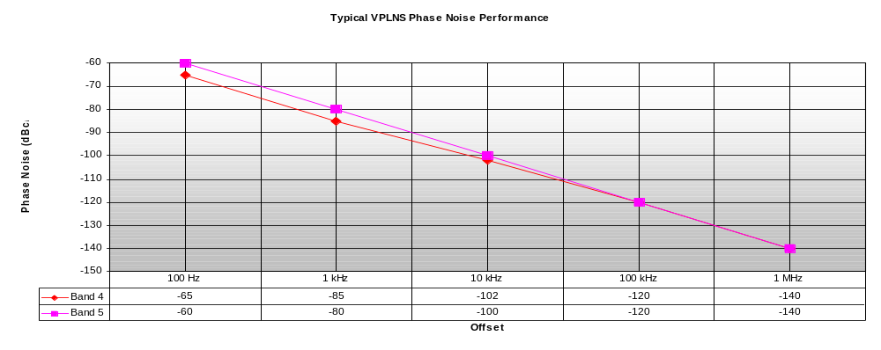
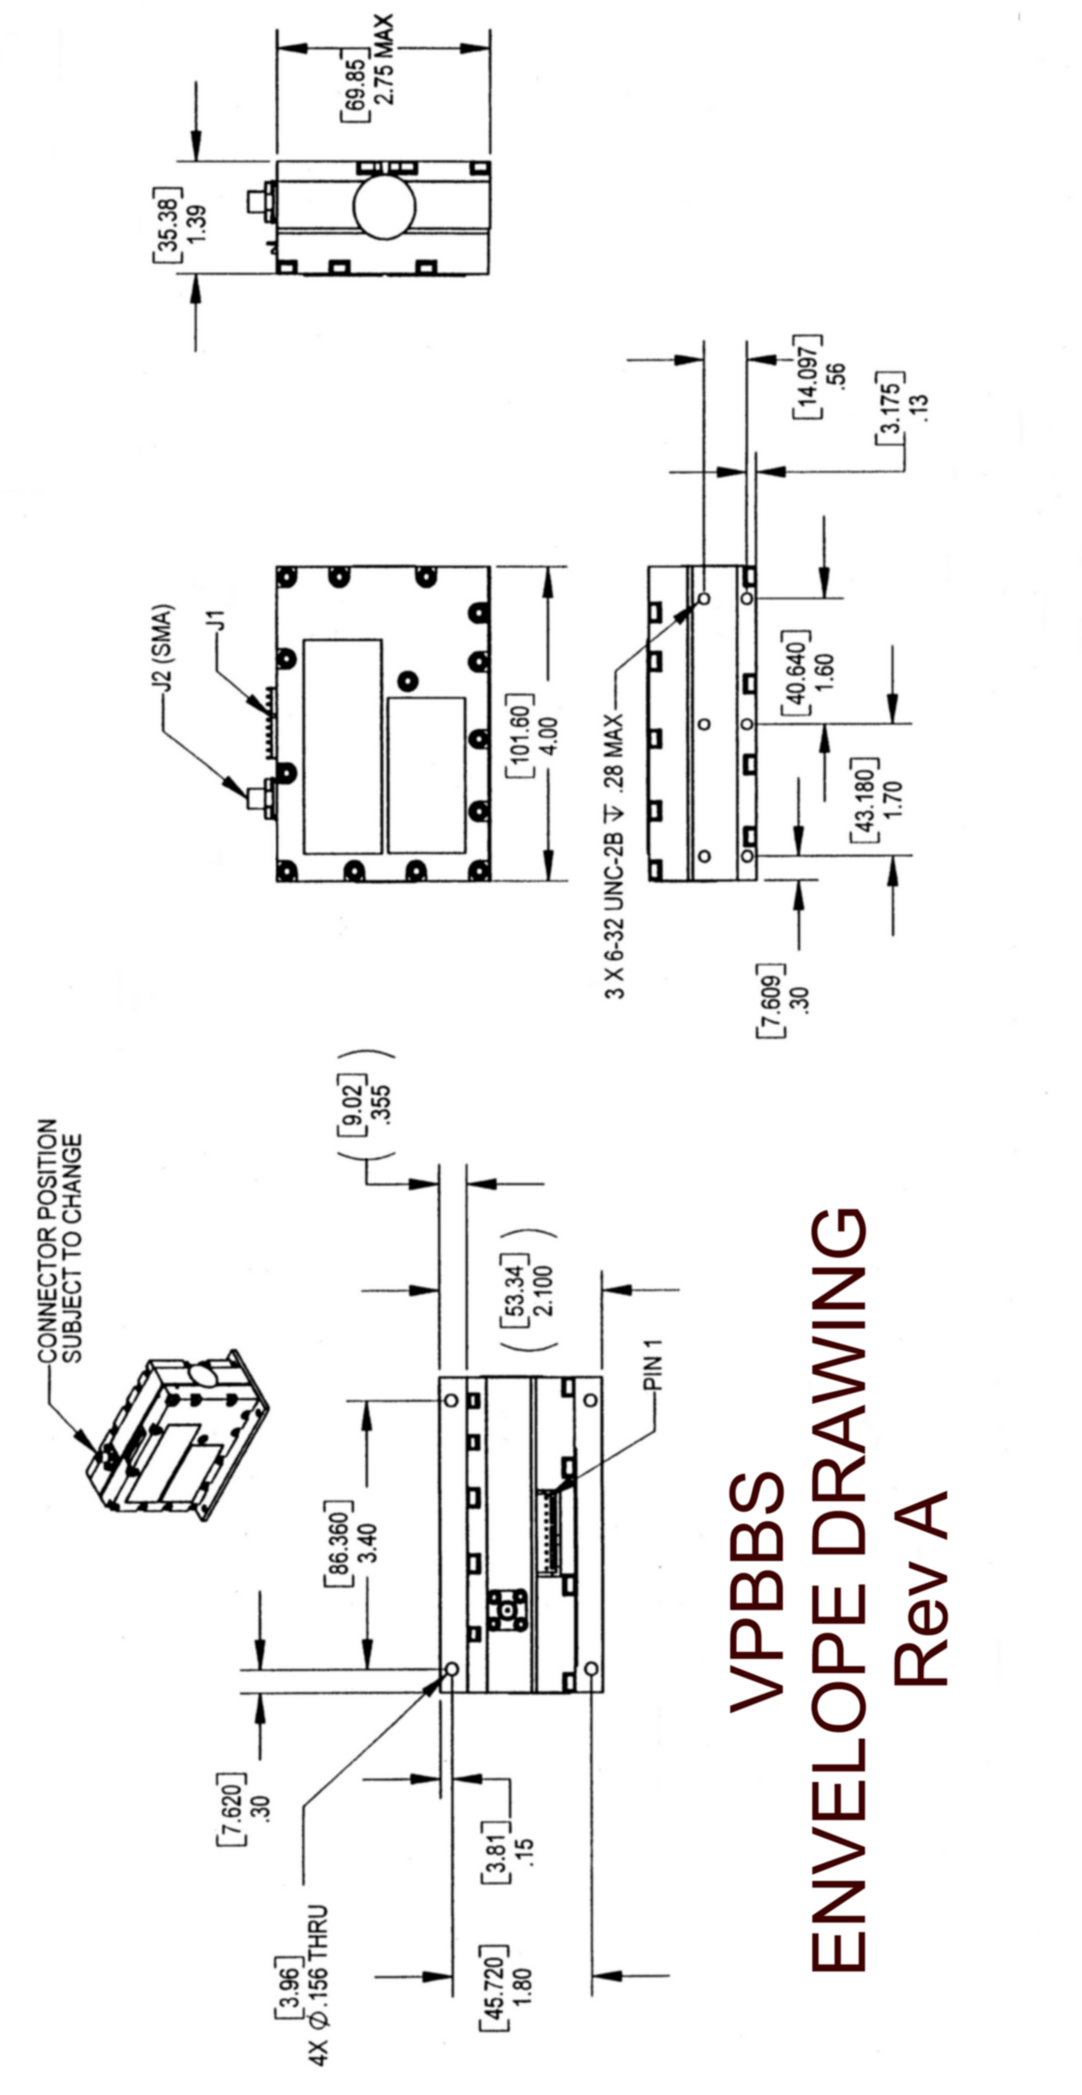

Communication Interface

The communication interface has been design to be compatible with an industry standard three wire serial load interface for frequency programming. Contact VIDA Product for application information.

3 WIRE SERIAL INTERFACE:

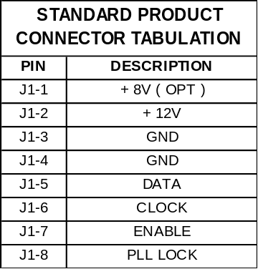

Ordering Information

To place an order, contact the VIDA Products Marketing Department at (707) 541-7000.

