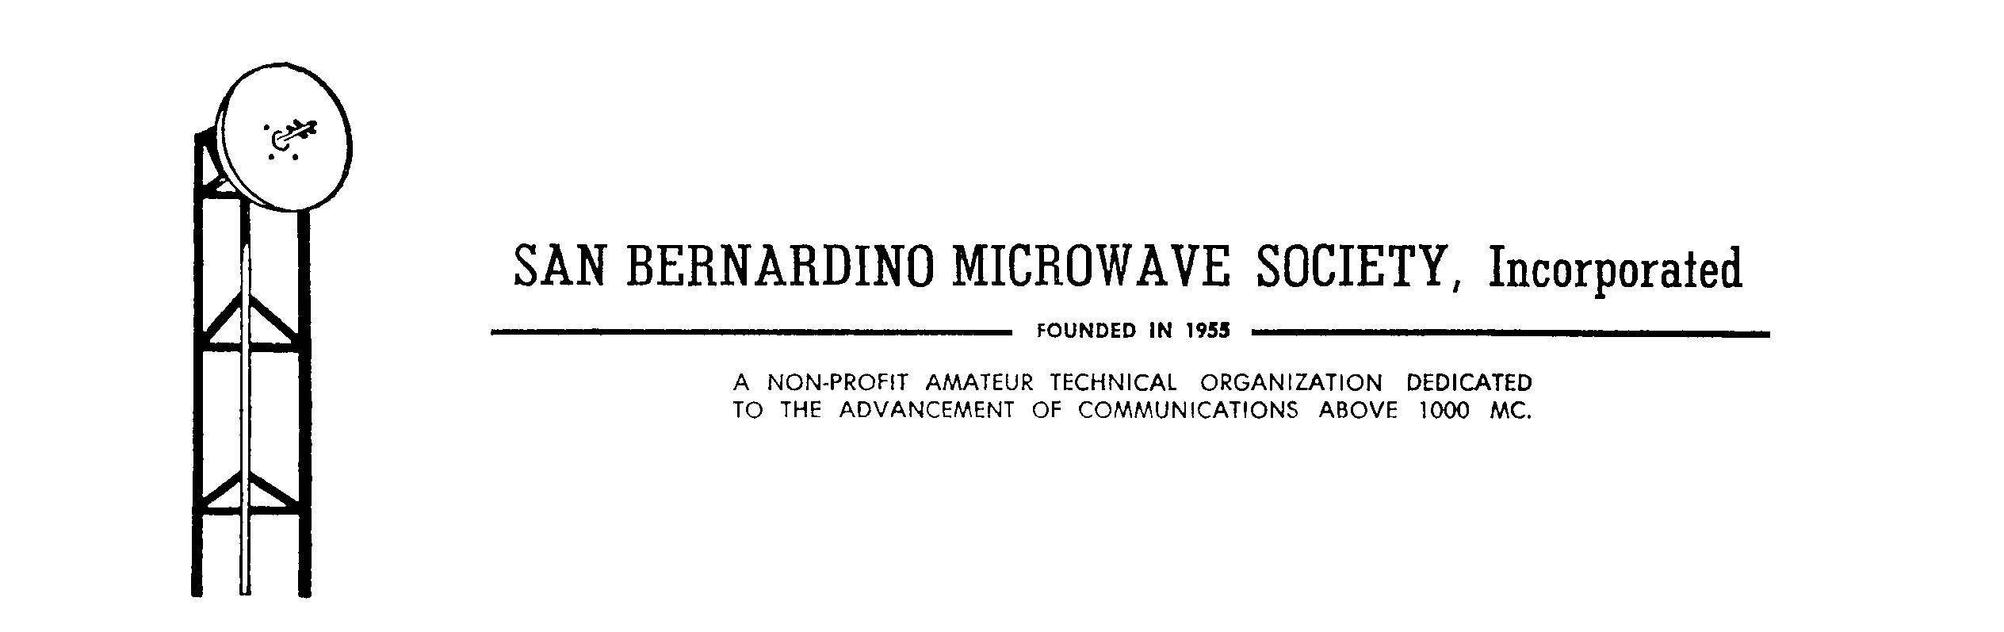

Application for Membership

Name ______________________________________________________________________________
Last First Middle initial Callsign

Address ____________________________________________________________________________

Home Phone _________________________ Cellular Phone ___________________________

Email Address _______________________________________________________________________

Areas of interest:

___Technical Advancement ___Social Activities ___Operating Activities ___Other

Recommended by ____________________________________

I will abide by rules and regulations set forth in the Society’s charter and by-laws.

Signed: ____________________________

Date: ________________

Membership annual Dues: $15.00

__________________________________________________________

Approved by:
___________________________ office ____________ date _______

___________________________ office ____________ date _______

Please make your check payable to “SBMS” and mail with this application to:

SBMS
417 SOUTH ASSOCIATED RD # 146
BREA, CA 92821
2019-07-28 MAW

